Dynamic Data Forms, Reports, & Charts
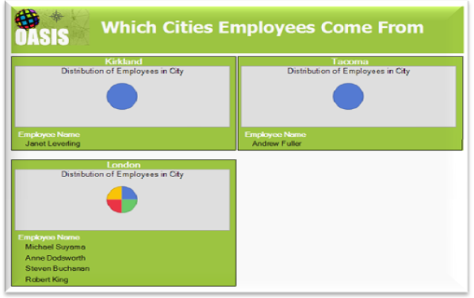
Contents
File Structure 2
Dynamic Database Schema 3
Master table 3
Linked tables 4
Data definition tables 4
Report Design 5
Report Title 5
Inserting Charts 5
Creating Chart Templates 7
The XML Report Definition File 7
Connection String 7
Images 7

File Structure
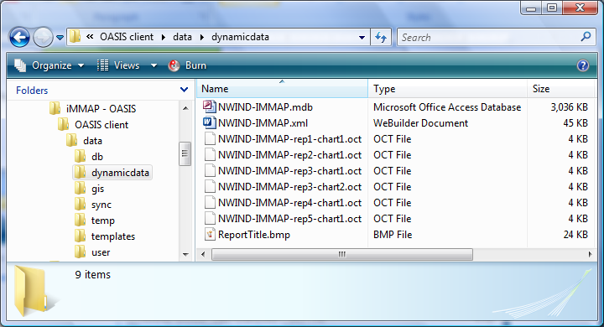
A folder named “dynamicdata” should be created in the location shown above. This folder will contain:
- The dynamic database (mdb file)
- The reporting template (xml file)
- The chart template definitions (oct file)
- The report logo (ReportTitle.bmp)
Please note that the mdb, xml, and oct files are named the same, for example:
NWIND-IMMAP-rep1-chart1.oct
NWIND-IMMAP-rep2-chart1.oct
NWIND-IMMAP-rep3-chart1.oct
NWIND-IMMAP-rep3-chart2.oct
NWIND-IMMAP-rep4-chart1.oct
NWIND-IMMAP-rep5-chart1.oct
NWIND-IMMAP.mdb
NWIND-IMMAP.xml

Dynamic Database Schema
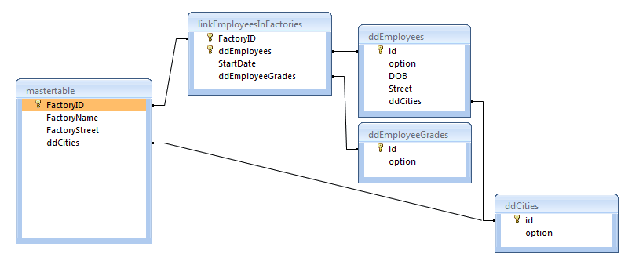
Database needs to be setup with 3 different types of tables:
- A master table
- Linked tables
- Data definition tables
Criteria for each table:

Master table
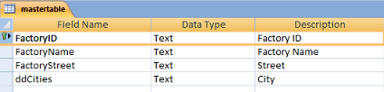
- There can only be one master table
- MUST be named as mastertable (case sensitive)
- First field MUST be a text field and the primary key
- All fields which are of a defined data set MUST be named the same as the tablename from which the data definitions come from (i.e. ddCities) (case sensitive) & these fields MUST be of text field type
- All fields MUST have the field caption to be displayed written in the “Description” parameter
- No spaces in the field name names

Linked tables
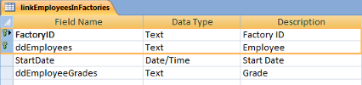
- MUST be named as link…… (case sensitive)
- First two fields MUST be text fields and the composite key
- All fields which are of a defined data set MUST be named the same as the tablename from which the data definitions come from (i.e. ddEmployeeGrades) (case sensitive) & these fields MUST be of text field type
- All fields MUST have the field caption to be displayed written in the “Description” parameter
- No spaces in the table name names
- No spaces in the field name names

Data definition tables
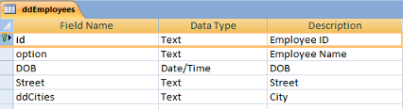
- MUST be named as dd…… (case sensitive)
- First field MUST be a text field, the primary key, and called “id” (case sensitive)
- Second field MUST be called “option” (case sensitive)
- All fields which are of a defined data set MUST be named the same as the tablename from which the data definitions come from (i.e. ddCities) (case sensitive) & these fields MUST be of text field type
- All fields MUST have the field caption to be displayed written in the “Description” parameter
- No spaces in the table name names
- No spaces in the field name names

Report Design
These reports should be designed using the OASIS Report Designer and is explained in this document. It is assumed that users of this tool are power users of Microsoft Access reporting tools.

Report Title
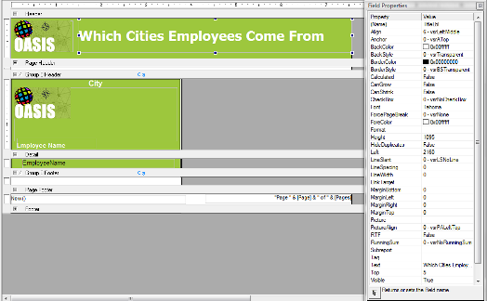
The title of the report should be named: “TitleLbl”

Inserting Charts
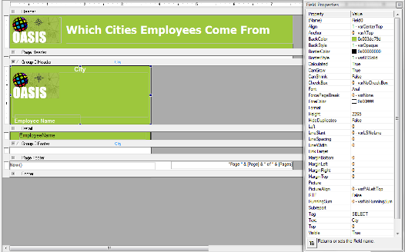
If you need to filter the chart by the current value displayed in the grouping then ensure there is a textfield named “Field0” with the Text parameter = to the filtering parameter.
For example, the chart we want to display should be filtered by the respective City, hence the name of the textfield is “Field0” and the Text parameter = “City”
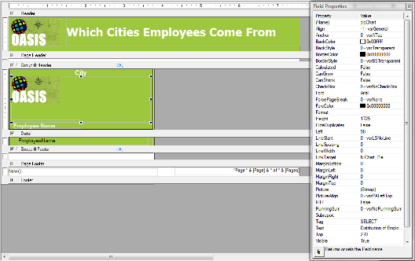
Next add a BoundPicture with the following properties
Property: Name
Description: Name of the PictureFrame
Value: picChart
________________________________________________________________________________
Property: Tag
Description: SQL Statement used to display the chart – you can filter by the Field0 value explained above. In order to accomplish this ensure you put XXXX in where you would like to have the filter value specified. You can only have 1 filter.
Example:
SELECT ddEmployees.option AS [NumEmployees], 1 FROM ddEmployees WHERE City = 'XXXX'
________________________________________________________________________________
Property: Text
Description: The name of the chart template file
Example: If the filename of the chart template is named as “NWIND-IMMAP-rep3-chart2.oct” then this value should be set to “rep3-chart2.oct”

Creating Chart Templates
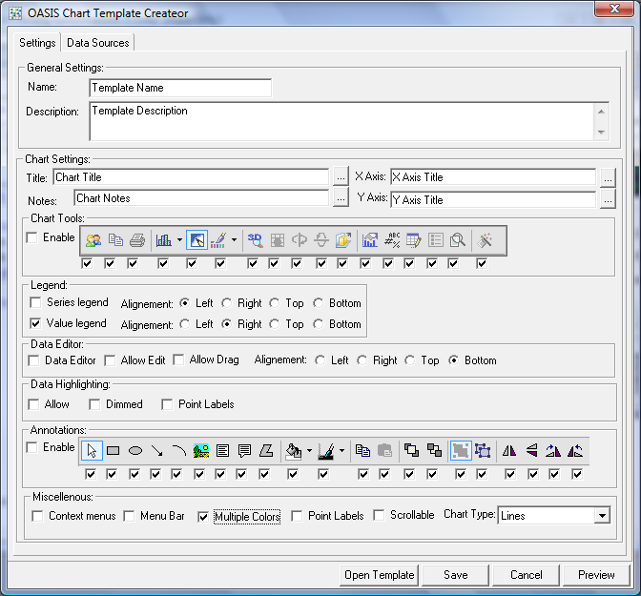
Define the chart template settings using the “Chart Generator Tool”. Do not define any data sources and save the file to the file structure outlined in this document and named in the correct format.
For example: “NWIND-IMMAP-rep3-chart2.oct”

The XML Report Definition File

Connection String
Ensure that all connection strings look like:
<ConnectionString>Provider=Microsoft.Jet.OLEDB.4.0;Data Source=NWIND-IMMAP.mdb;Persist Security Info=False</ConnectionString>
(note that the “NWIND-IMMAP” name should be EXACTLY the same name as the XML file and located in the same directory)

Images
<Picture>ReportTitle.bmp</Picture>
(note that the “ReportTitle.bmp” must be located in the same directory as the XML file)

